**Testing Category and Product APIS using POSTMAN**

Postman is a popular tool used for developing, testing, and documenting APIs. It provides a user-friendly interface to make HTTP requests, test responses, and debug web services. It supports various types of HTTP methods (GET, POST, PUT, DELETE, etc.), making it a perfect tool for testing CRUD (Create, Read, Update, Delete) operations in APIs.

**Categories:**

1. POST(Create):

To create a new resource in the database.

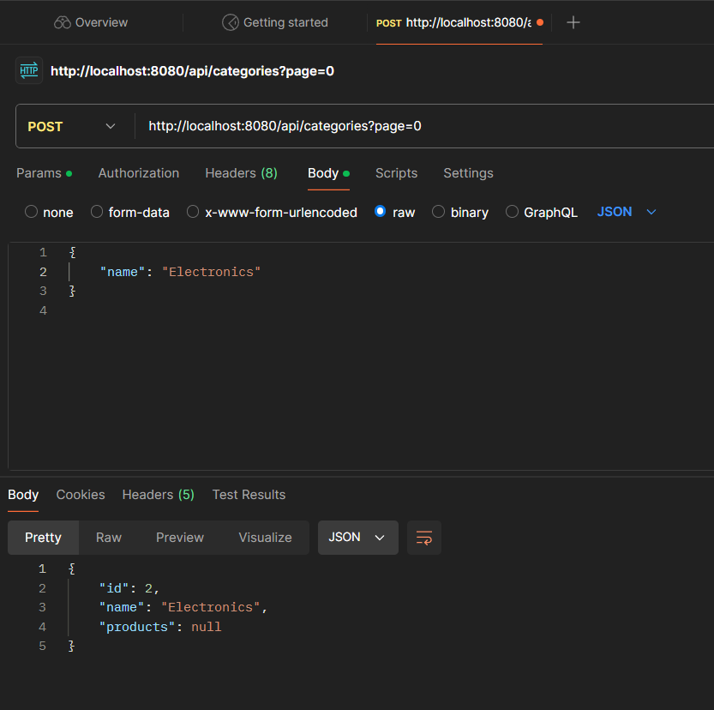

1. GET(Read): To retrieve data or list of resources from the database.

1. PUT(Update): To update an existing resource in the database.

1. DELETE: To remove a resource from the database.

**Products:**

1. POST

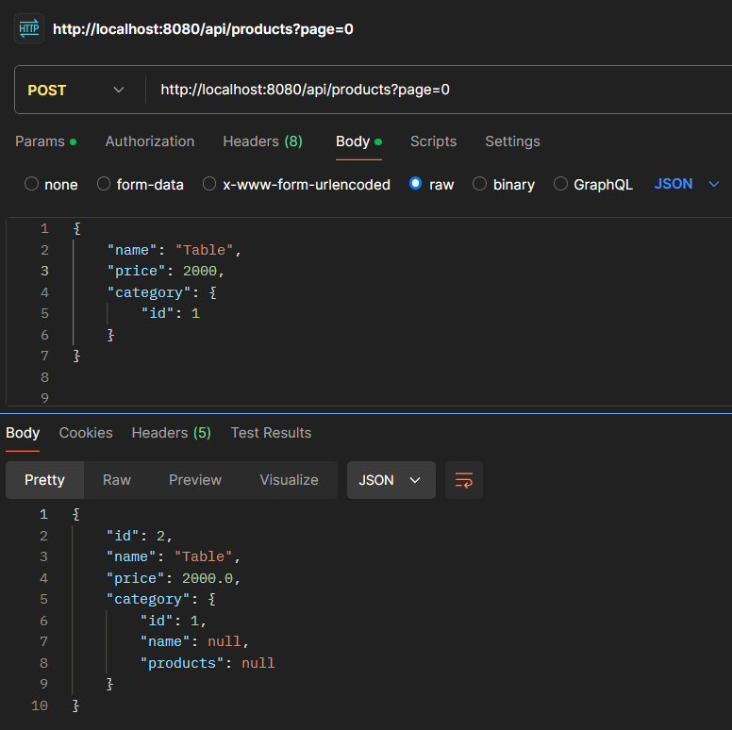

1. GET

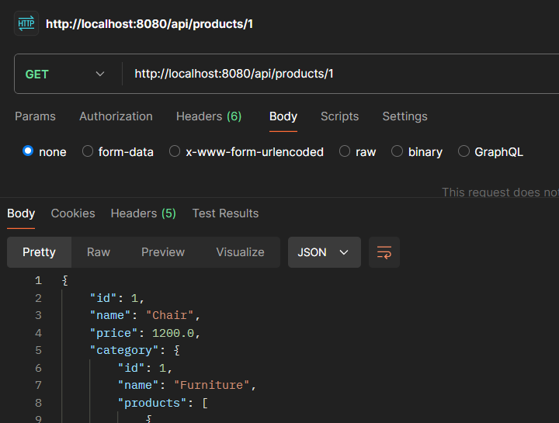

1. UPDATE

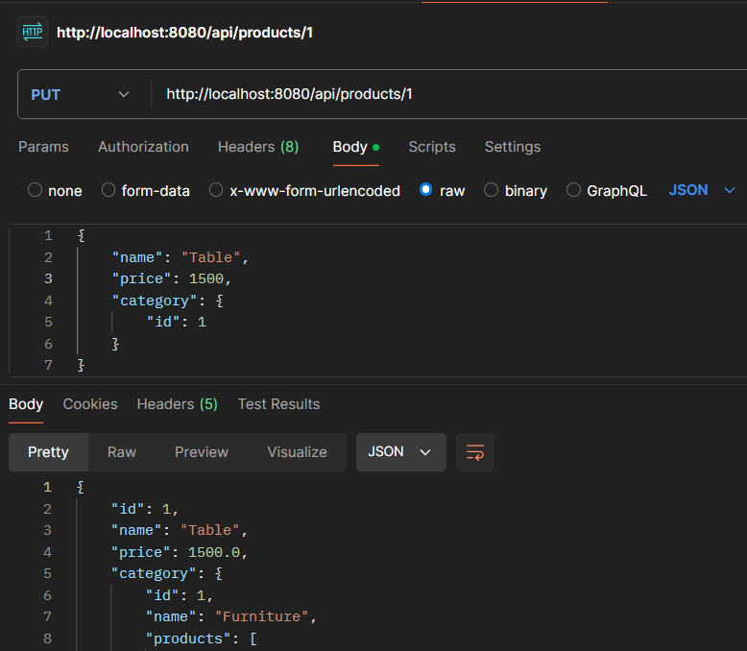

1. DELETE

